[E126] Power button

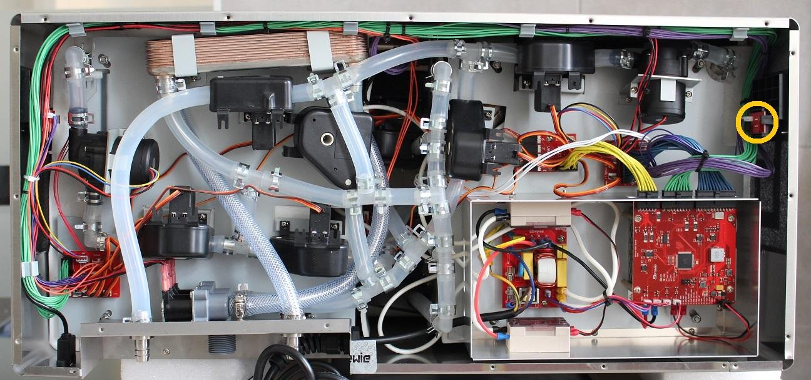

First disconnect the cable of the drain button then the button PCB can be popped out from the mounting easily by stretching back either of the black plastic clamps.

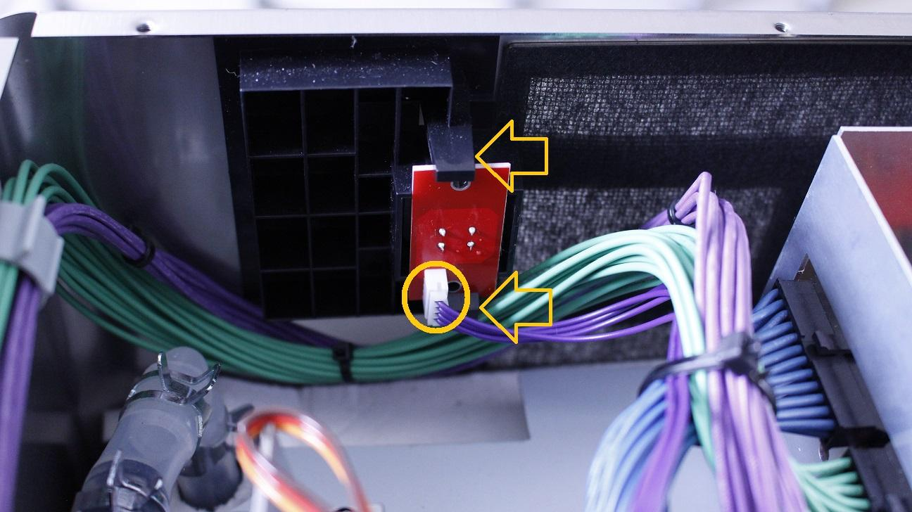

Now the button unit can be replaced.

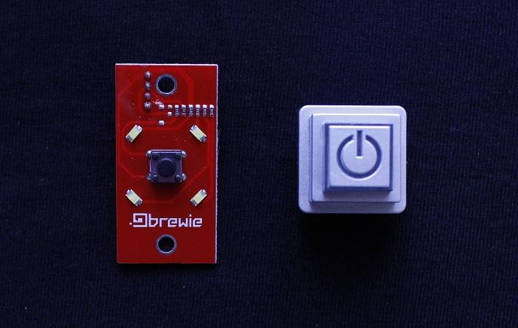

IMPORTANT!

When replacing the drain button:

Be careful with the silicone flange around the button while reassembling the button!

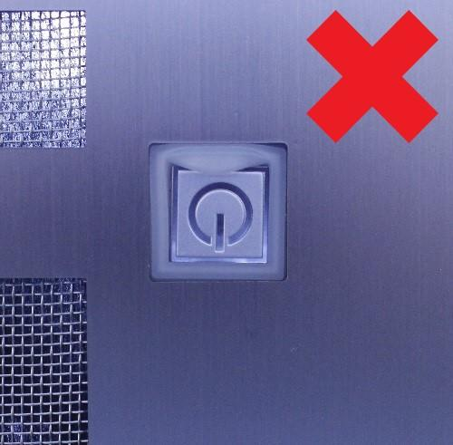

Pay attention to the orientation of the power button.

